Summary of DA-PWC Performance

Data
Data for this analysis were taken from Region 5 (41870 points total) of the Fungi sequence classification at http://salsahpc.indiana.edu/millionseq/fungi2/fungi2_index.html
Dataset | # Points | # Clusters | Description
A | 12579 | 4 | Region 5 sub cluster 2 (of 10) split into 4 (# clusters)
B | 20000 | 10 | Region 5 first 20k points split into 10 clusters
C | 40000 | 10 | Region 5 first 40k points split into 10 clusters

Parallel Libraries
Dataset | C# |  | Java
 | MPI | Tasks | MPI | Tasks
A | MPI.NET v1.0.0 | Microsoft Task Parallel Library .NET v4.0 | OpenMPI v1.7.5rc5 | Habanero Java (HJ-lib) v0.1
B | MPI.NET v1.0.0 | Microsoft Task Parallel Library .NET v4.0 | OpenMPI v1.8.1 | Habanero Java (HJ-lib) v0.1.1
C | MPI.NET v1.0.0 | Microsoft Task Parallel Library .NET v4.0 | OpenMPI v1.8.1 | Habanero Java (HJ-lib) v0.1.1

Parallelisms
Total | T | P | N | Total | T | P | N | Total | T | P | N
Where,
T - # of concurrent tasks per MPI process
P - # of MPI processes per node
N - # of nodes

Dataset | Parallelisms Tested
A | 1,2,4,8,32,64,128,256
B | 64,128,256
C | 64,128,256

System Information
System | Description
Tempest | 32 nodes, each has 4 Intel Xeon E7450 CPUs at 2.40GHz with 6 cores, totaling 24 cores per node; 48 GB node memory and 20Gbps Infiniband (IB) network connection. It runs Windows Server 2008 R2 HPC Edition – version 6.1 (Build 7601: Service Pack 1).  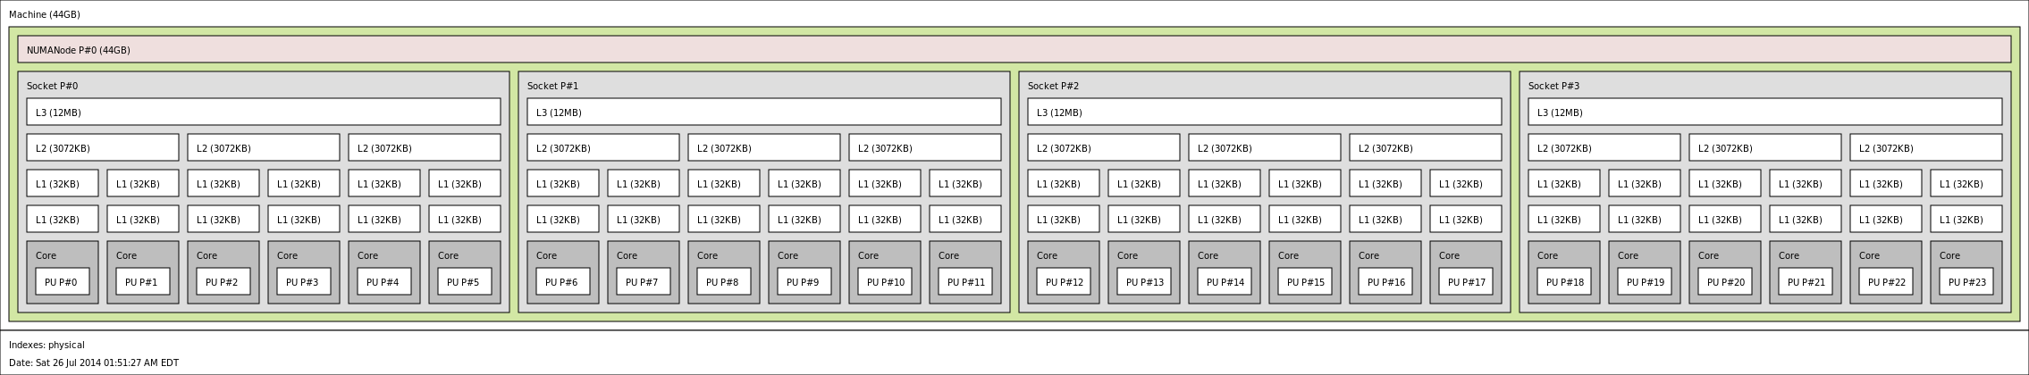
FutureGrid - India | 128 nodes, each has 2 Intel Xeon X5550 CPUs at 2.66GHz with 4 cores, totaling 8 cores per node; 24GB node memory and 20Gbps IB network connection. It runs Red Hat Enterprise Linux Server release 5.10.  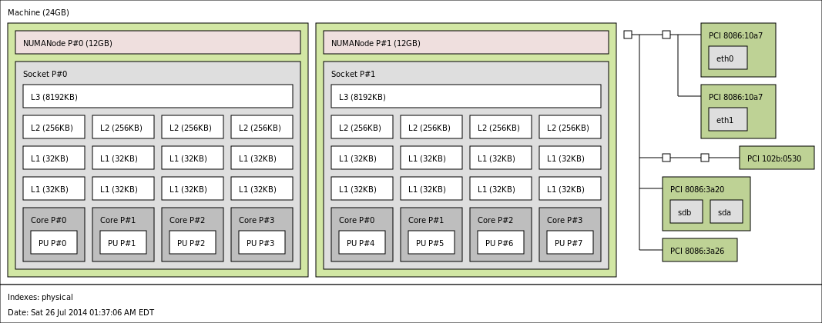

Performance Results

Dataset A – 12579 Points

Note, the TxP patterns that gave the best performance for a given number of node is highlighted in blue rectangle.

The highlighted section of above graphs is presented below.

The above graphs shows 4 different intra-node parallelism patterns – 1x8, 2x4, 4x2, and 8x1. Note how 8x1 performs poorly compared to the other three in OMPI. This happens due to the topology of FutureGrid machines where a socket contains only 4 cores. Therefore running 1 MPI with more than 4 tasks doesn’t yield good performance.
The best pattern for OMPI happens to be 1x8 – highlighted in green.

A different representation of the above graph shows the effect of TxP patterns more clearly.

Dataset B – 20k Points
// TODO

Dataset C – 40k Points

Note how 1x8 keeps the best performance still for this data

